Dear Colleagues,
Paper 4/2019: Values-Based Policy-Making
After the 2017 general election, the CPF led a Party-wide consultation into Conservative values. Now, with the election of a new Party Leader and new Prime Minister, we want to give Members the opportunity to reflect again on who we are as a Party and how our values should be reflected in the policies that we seek to champion and implement.
In recent years, the CPF has facilitated five national policy discussions each year. Necessarily, even when these are fairly broad ranging, this cannot create the space for discussion across all the areas of policy that are of interest to different members. This discussion paper breaks free of those constraints and invites supporters of the Party to suggest policy ideas for any sphere of how we organise ourselves as a society.
This topic is a change from what we originally advertised, so apologies to those of you who were looking forward to discussing under-18s education. We could have proceeded with a policy discussion on this subject, but it makes sense to use the Party’s transition in leadership to broaden our focus. Also, by waiting until the new education team are in place, it means that when we do discuss education, later in the year, our suggestions will be more relevant to both the vision cast by the new PM and the priorities of the new Secretary of State.
To generate even wider discussion and debate, why not record short videos (of less than 30 seconds duration) of individuals stating what values-based policy they are proposing (“As Conservatives, we believe in …”) and what their policy idea is (“so we should…”)? Then post it on social media using the hashtag #CPFMembersManifesto. E.g. “As Conservatives, we believe in living within our means, so we should borrow only to invest in infrastructure.”
We want as many associations and members as possible to engage in this wide-ranging discussion. So, we are launching this consultation before the summer break and invite groups to send their responses at any time until 20 October. The closing date for our discussion on the Post-Brexit Economy remains 31 August. Please send your responses via CPF.Papers@conservatives.com, using the associated response form published alongside this paper in the News section of the CPF website. Our next paper will then be on Under-18s Education. This will be published in the third week of October and will run to the end of the year. Thank you for your understanding and your participation.
Discussion | Publication date | Deadline for responses
Post-Brexit Economy | 7 May | 31 August
Values-Based Policy-Making | 24 July | 20 October
Under-18s Education | w/c 21 October | 31 December
A summary of responses to this discussion paper will form the basis of a CPF Members’ Manifesto and will be sent to the Prime Minister, Party Chairman and CPF Chairman within a month of the closing date for submissions. We look forward to hearing your ideas on this important topic.
The CPF Team
John Hayward Flick Drummond Andrew Sharpe George Freeman
CPF Manager Voluntary Director Vice-Chairman Chairman
www.conservativepolicyforum.com
@ConservativePF
P.S. As always, discussions will be more greatly informed if groups are able to include members and non-member supporters of the Party from different age groups.

Context
“So far as is practical the Parliamentary and Voluntary Party, through CPF, in a sudden election should have an opportunity to make suggestions for inclusion in the Manifesto.” (Sir Eric Pickles, General Election Review 2017)
Values-Based Policy-Making
After the 2017 general election, the CPF led a Party-wide consultation into Conservative values. Now, with the election of a new Party Leader and new Prime Minister, we want to reflect again on who we are as a Party and how our values should be reflected in the policies that we seek to champion and implement.
We have grouped under three key headings, 24 values that capture that main ideas proposed by members through our values consultation. For each of these 24 values, we want groups to name ONE policy that they would like to propose. Groups do not have to suggest a policy for every value but you must constrain yourself to your best suggestion for each value and we will only consider one policy per value from each group.
In case you need any help in considering what social, political and economic challenges you might seek to apply our shared values to, here are the latest findings on what issues most concern the public:
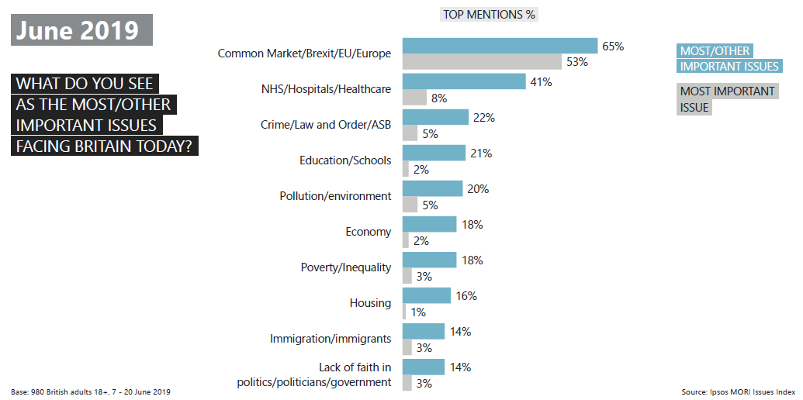
Others included: Unemployment/Factory closure/Lack of industry (11%/1%); Ageing population/Social care for the elderly (10%/1%); Defence/Foreign affairs/International terrorism (9%/1%); Public services (9%/1%); Low pay/Minimum wage/Fair wages (8%/1%); Drug abuse (8%/*); Pensions/Social security/Benefits (6%/*); Inflation/Prices (6%/1%); Race relations (5%/*); Taxation (5%/*); Transport/Public transport (5%/*); Morality/Individual behaviour/Lifestyle (4%/*); Local government/Council tax (4%/*); Population levels/Overpopulation (3%/*); Petrol prices/Fuel (3%/*); Animal welfare (2%/1%); Countryside/Rural life (2%/*)
Values
As members of the Conservative and Unionist Party, we are united by our core values of freedom, responsibility and enterprise.
Freedom
We are committed to:
- liberty and democracy
- freedom of choice
- free speech
- strong national defence
- security and safety
- justice and the rule of law
- localism and limited government
- national sovereignty and patriotism
Responsibility
We are committed to:
- equality of opportunity for all
- social justice and fairness
- families and the vulnerable
- compassion and respect
- diversity and inclusion
- tolerance and openness
- honesty and integrity
- pragmatism and sustainability
Enterprise
We are committed to:
- leading internationally
- supporting a responsible free market economy
- living within our means
- delivering and obtaining value for money
- education, aspiration and empowerment
- social and economic mobility
- local communities
- being forward-looking
Name ONE policy that your group would like to propose for each value. Groups do not have to suggest a policy for every value but you must constrain yourself to your best suggestion for each value.

Issues Index June 2019: Brexit continues as Britain’s biggest concern and worry over pollution and the environment remains high, Ipsos Mori, 31 May 2019, link

