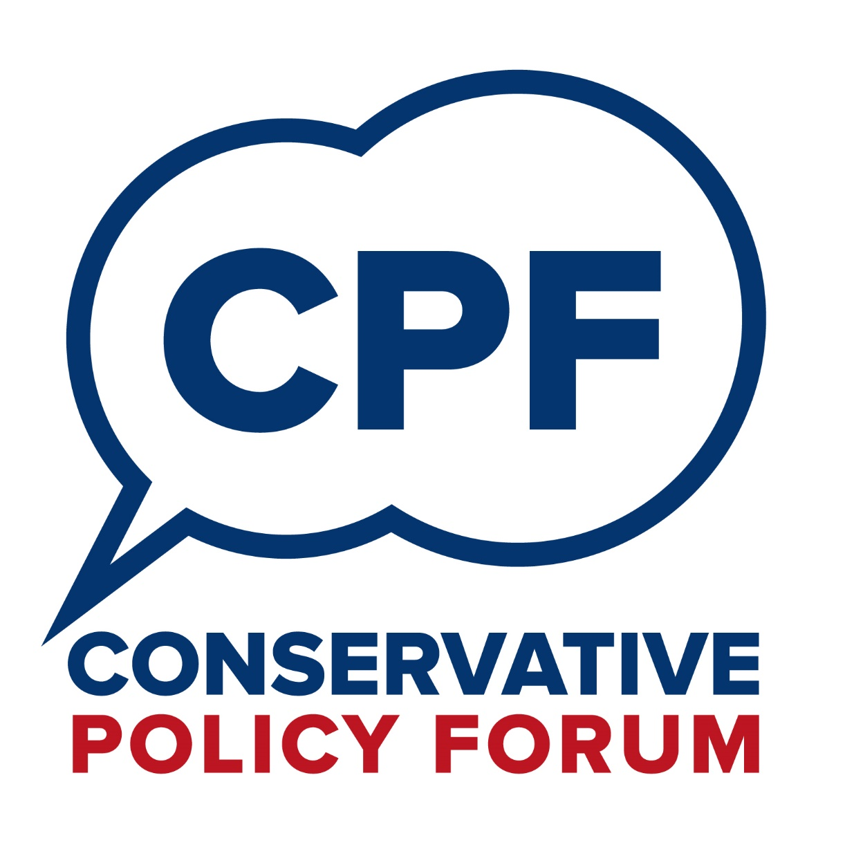
CPF Pack
CPF Communications Structure 1
Set-Up Guide for New Groups 3
Individual Registration Form 8
Group Registration Form 9
Event Registration Form 10
Discussion Attendance Form 11
Updated June 2019

What we do
The Conservative Policy Forum:
• develops and advances Conservative ideas and policies within the Party and in Government for the benefit of the whole country;
• creates regular opportunities for all members, regardless of age or location, to discuss the challenges facing the country and to have real influence on Party policy;
• champions Conservative policies locally and nationally so as to support the election of Conservative candidates at every level of government.
Communications Structure
Business plan
Policy papers and responses
Group assistance and development
Discussion papers and ministerial responses (via email)
Local meeting arrangements and papers
New/Updated Group details
CPF Manager
CPF Champions
CPF Group Coordinators
CPF Group Members
Individual registration (via website)
Group registration
(via emailed form)

Discussion responses
(via emailed form)
CPF Chairman
No.10 Policy Unit & Ministerial Special Advisers
Outreach plans
CPF Voluntary Director

The CPF Voluntary Director is elected to drive forward the work of the CPF within the Voluntary Party, working alongside the professional team to ensure effective day-to-day operational management, ensuring that CPF has a presence at all national and regional conferences, and producing an annual business plan.
The CPF Manager is responsible for developing the national policy discussion to help inform and implement future Conservative policies. The CPF Manager is the key contact between the Party’s senior volunteers with an interest in the CPF and the professional staff, both within the Conservative Party and with the PM’s Policy Unit and Ministerial Special Advisers.
CPF Champions support the Party’s policy development and outreach work by building a network of voters on the frontline of their communities. They liaise with the CPF Chairman on policy development with Ministers, work with the CPF Manager to support development of CPF policy consultations, and help the CPF Voluntary Director to support relevant outreach work.
Group Coordinators are responsible for organising Group meetings, broadening local participation, chairing discussions, and sending discussion responses to the CPF Manager. When a new CPF Discussion Paper is released, the Group Coordinators will ensure that a date and venue for a meeting has been agreed and circulated to all Members in the Association/Federation.

- Objective
CPF Groups contribute to the campaigning strength of an Association. They are a great way to involve people who have an interest in thinking about the way Conservative Party ideas and policies should be developed. As such, they provide an important extra dimension to membership of our Party.
The CPF is the vital link between ordinary Members of the Party and Government. The CPF makes it clear to every Conservative Member that no matter who you are, where you live, or what your experience of politics is, your voice will be heard and will count.
So, having a strong, effective CPF as part of your Association is another great way to attract, engage and increase your membership. This document has been prepared to help you get started.
- Building Membership
Setting up a CPF Group should be a priority for your Association. However, if it is going to be successful it needs support from the Officers (especially the Political Deputy Chairman, who is responsible for the CPF) and the Executive Council, so it is important to consult them. It is also important that, once your CPF Group has started meeting, you report back to them regularly so that they remain fully engaged in the work that you are doing.
The most important element is to inform your Association’s members, supporters and potential supporters that the CPF is fully operational and that there will be a range of policy documents in the pipeline. At the end of this document is a draft email/letter that could be sent out by the Association Chairman or CPF Coordinator, explaining to your Members what the CPF is and why they might like to participate in forthcoming debates.
- Where Do I Start?
You might want to start the process by building on existing structures and activities, for example, introducing CPF activity into the programme of an existing supper club or within your regular meetings. If you would like to set up a dedicated CPF Group, your first step should be to form a small steering group, involving the Political Deputy Chairman and to nominate a CPF Coordinator and Secretary.
- Registration
It is important that each CPF Group is registered with the CPF Manager using the Group Registration Form in this Pack. The CPF is committed to providing regular updates and timely feedback on all the national issues that are debated. Registration of Groups and maintaining accurate attendance records, using the Discussion Attendance Form in this pack, ensures that all participants receive these regular communications.
- CPF Group Branches
In large rural constituencies, it might be more appropriate to have more than one CPF Group as the distances involved in travelling from one part of the constituency might be considerable. CPF Groups can be any size and can also be established to focus on one particular community or area of interest, so long as the group remains open to all. Examples include University CPF groups and Business CPF groups.
- Managing CPF Members
Having contacted all of the Members, it is important that they are “registered” as being interested in attending CPF events, so that both the Group Coordinator and the CPF Manager can keep them informed of forthcoming activities and papers. Details of all Members who register via the CPF website will be recorded via the “CPF Members” tag on VoteSource. Use of the Discussion Attendance Form in this Pack enables Group Coordinators also to keep a record of contact details for Members, ensuring that nobody misses out on important communications about local, regional and national CPF events and policy discussions. Group Coordinators will pass on copies of all messages and papers to Members who prefer paper to electronic communication.
- Data Management
Group Members’ personal data should be securely stored on VoteSource. Using the “CPF Members” tag on VoteSource to record a Member’s interest in policy development makes it easy to send information and feedback about discussions to the relevant Members.
All volunteers and staff handling personal data must abide by 'P3P' standards (the 'Platform for Privacy Preferences Project') on data privacy. Any information collected and stored on behalf of the CPF must never be sold, shared, rented or used for personal purposes. The sole reason that the CPF asks for contact details is to keep Members informed of CPF discussions and events. The reason we ask for other personal details is in order to ensure that the CPF and its discussions are representative of all ages, regions and interests. No other use is permitted.
- Event Management
The event venue will be dictated by the timing of the meeting and the size of the audience. A room within the local Conservative Club is the most obvious choice, but also a local pub or a Member’s private house are other options. One Group Coordinator has observed, “After some experimentation, we have found that the most successful option is meeting in the early evening in a private room at a pub that provides bar meals. This has also enabled some subject matter experts such as MEPs to attend.”
The event should be well publicised in plenty of time to all Party Members, supporters and , even those that have not expressed an interest in the CPF, as the specific topic might be something that they would want to discuss.
The CPF is open to all Members of the Conservative Party and potential supporters from throughout the UK. CPF events must reflect the full range of views and opinions of Party Members, thus enabling and facilitating open and wide debate. Organisers of CPF events should prioritise neutrality in event organisation, for example ensuring that differing viewpoints are represented when speakers are invited.
Groups are encouraged to organise and register special events with the CPF using the pro forma registration form enclosed in this Pack. These might be organised with one of the Party’s Outreach groups, across neighbouring constituencies, or could be area and regional events. These should be arranged through and with the Party’s Area and Regional Committees. This will enable the CPF to advertise the event (if desired), help to arrange speakers to attend (where needed), and keep other CPF members informed of wider CPF activity throughout the UK. Should Members need the CPF to help organise speakers, adequate notice of the event should be given. Registration is not expected or required for regular discussion meetings.
- MP Involvement
In Conservative-held constituencies, it may be helpful to have a strong endorsement from your MP to launch the CPF Group in your Association. The MP or other Conservative elected representatives for the area could use their social media channels and other forms of communication to raise the profile of CPF. The MP might wish to attend the first or subsequent Group meetings, particularly if the discussion is about an area in which they have a particular interest or expertise. However, the MP may also feel that their presence at a meeting might inhibit discussion, as the room could acquiesce to their knowledge and position. If they do not attend, it would nevertheless be helpful for the Group Coordinator to invite their input prior to the meeting so that Members can be informed of the MP’s position and any useful insight that they might have to offer.
- Local Councillors
Although Councillors have to attend many meetings, their input into CPF can be invaluable. They bring a local knowledge and understanding of issues important to the day-to-day operations of local government that could provide a helpful insight into the conclusions drawn from the CPF meeting. They might also be a conduit for providing the material for local CPF meetings – see (12) below.
- National Discussion papers
CPF papers cover topics from across the range of government departments and the plan is to publish national discussion papers at least five times a year, in January, March, June, September and November. Papers will be published at the start of the month and the deadline for submitting responses will be the end of the following month. Thus, the CPF will give Groups at least eight weeks to complete the cycle of meeting and submitting a report back to the CPF Manager. Reports should be sent by email to CPF.Papers@Conservatives.com using the template accompanying the discussion paper.
- Debating Local Issues
In addition to national CPF Papers, Groups may occasionally decide to debate important local issues. These will vary from constituency to constituency, but they could be done in consultation with the MP and local Councillors. Local issues such as health or education could provide the platform for an interesting debate if local experts were asked to attend and address the audience.
- Follow-up Discussions and Ministerial Feedback
Following the deadline for submission of reports by Groups, the CPF Manager will collate responses and present these to the Prime Minister’s Policy Unit. The Policy Unit will ensure that the policy suggestions feed into future policy development. Where appropriate, representatives from CPF Groups will be invited to a roundtable discussion with the Policy Unit in order to explore their ideas in further detail. A Ministerial reply will subsequently be prepared and circulated to CPF Groups, usually within a month of this.
- Communications
It is important that all Party Members know about the activities of the CPF. Group Coordinators and Association Officers should consider sending a copy of Group discussion reports to all members of the Association. Informing local Conservatives about the feedback going into Ministerial Departments will help to build the presence of CPF and encourage involvement.
Members must ensure that any use of social networking sites to promote CPF activities does not breach the Party’s requirement that Members do not compose, disseminate or promote content which is illegal, offensive, in bad taste, immoral or could otherwise be a source of embarrassment to the Party.
- Regional Assistance
Political Deputy Chairmen in each local association are responsible for ensuring that there is an active CPF group, by which members' policy concerns can be heard.
The Conservative Party’s Area and Regional Officers can also be called upon to provide support for association officers, where needed.
Area Deputy Chairmen should be in regular contact with Political Deputy Chairmen and CPF Coordinators in their region to ensure that everything is progressing well in the individual Associations. By finding out what has worked well, they can also help to identify “best practice” and help other CPF Groups across the country learn and develop from new initiatives.
When a CPF Group holds a local CPF meeting that might be relevant to neighbouring Associations, then Group Coordinators can contact their Area and Regional Officers, as well as the CPF Manager, to help promote this event and try to generate additional attendance.
- Inclusion
The CPF is committed to promoting equality of opportunity and to creating an environment in which all individuals are able to make best use of their skills, free from discrimination or harassment, and in which all decisions are based on merit.
The CPF does not discriminate on grounds of age, disability, gender reassignment, marital or civil partner status, pregnancy or maternity, race, colour, nationality, ethnic or national origin, religion or belief, sex or sexual orientation (the “protected characteristics”). Everyone has a responsibility to uphold this policy and all CPF Group Coordinators and others representing the CPF are required to ensure there is no discrimination or harassment in their areas of responsibility.
- Template Letter/Email
For those who would find it helpful, the following template can be used by Association Chairmen, DCPs, or CPF Group Coordinators to inform Association Members about the CPF. Many Members may never have heard of the CPF before, even though Party membership entitles them to participate in the Forum.
Dear Member
Re: Conservative Policy Forum
I felt that you might be interested in becoming part of the team within our Association who will help to formulate the Conservative policy agenda during this administration and for the 2022 Conservative Manifesto.
Historically, the Conservative Policy Forum (CPF) was the conduit used by Conservative Ministers to debate elements of new policy with the grassroots of local Associations. Since 2016 the CPF Chairman has been George Freeman MP, through whom the CPF has a direct line to Ministers. In addition, the CPF Manager also meets regularly with the Prime Minister’s Policy Unit and the Conservative Party’s Vice-Chair for Policy. CPF Members provided an invaluable role in the preparation of the 2015 General Election manifesto and in explaining policies during campaigning.
Members should take satisfaction in these achievements. The CPF Voluntary Party Director, Flick Drummond, and CPF Manager, John Hayward are determined that Members continue to be able to influence the direction of the Conservative Party and our country. This is where you can play a huge part.
We expect there to be at least five national discussion papers for you to debate with other local Members each year. Each debate will be given sufficient notice so that as many of you as possible can attend and make your views known.
Also, we are being encouraged to use the CPF umbrella to have meetings to discuss and debate local issues within our own constituency.
In our Association these meetings will be chaired by AAAA BBBBB. AAAA will contact you with the time and location for all future meetings.
Please could you send our office manager, CCCC DDDDD, an email – office@association.co.uk - or please phone CCCC on 01234 567890 – to add your name to the list of Members wishing to be kept informed of future CPF events. Alternatively, you can register your interest via the CPF website, at conservativepolicyforum.com/join
The first CPF discussion will take place on DD-MMM at X.XXpm, and the second on DD-MMM at X.XXpm. We shall meet at ……
This is an exciting time for our Party and our country, with so many possible changes ahead. Make sure your voice is heard!

The Conservative Party Forum (CPF) is open to all Members of the Party and others sympathetic to the Party’s values. Members should register their details with the CPF in order to participate fully by completing and returning this form to both the CPF Manager via CPF@Conservatives.com and their Association’s CPF Coordinator, Political Deputy Chairman or Chairman. It can also be completed online at conservativepolicyforum.com/join
Title: First name:
Last name: Suffix:
Preferred salutation:
Year of birth: This helps us to demonstrate the CPF is representative of all ages.
Email address (CAPITALS):
Address line 1:
Address line 2:
Town/city:
Postcode: If overseas, please put the region code or area.
Constituency: If overseas, please enter country.
Telephone number: Mobile number:
Are you a member of the Conservative Party? ☐ Yes ☐ No (tick as appropriate)
Role in CPF or most senior current position in the Party (if any):
Which CPF updates do you want to receive?

☐ Policy discussions news only
☐ Policy discussions and events news only
☐ All policy discussions, events & campaigning news
(tick as appropriate)

Areas of interest (tick all that apply):

☐ Arts & culture
☐ Borders & immigration
☐ Business & enterprise
☐ Children & young people
☐ Climate change
☐ Community & society
☐ Consumer rights & issues
☐ Crime & policing
☐ Defence & armed forces
☐ Devolution
☐ Employment
☐ Energy
☐ Environment
☐ Equality, rights & citizenship
☐ Europe
☐ Financial services
☐ Food & farming
☐ Foreign affairs
☐ Further education & skills
☐ Government efficiency, transparency & accountability
☐ Government spending
☐ Healthcare & public health
☐ Higher education
☐ Housing
☐ International aid & development
☐ Law & the justice system
☐ Local government
☐ Media & communications
☐ National Health Service
☐ National security
☐ Pensions & ageing society
☐ Planning & building
☐ Public safety & emergencies
☐ Regulation reform
☐ Rural & countryside
☐ Schools & education
☐ Science, technology & innovation
☐ Social care
☐ Sports & leisure
☐ Tax & revenue
☐ Trade & investment
☐ Transport
☐ UK economy
☐ Welfare & benefits
☐ Wildlife & animal welfare

The Conservative Party Forum (CPF) strives to meet 'P3P' standards (the 'Platform for Privacy Preferences Project') on data privacy. We are the sole owner of any information we collect. We never sell, share, or rent this information. We ask for your contact details to keep you informed of CPF discussions and events. We ask for other personal details in order to ensure that the CPF and its discussions are representative of all ages, regions and interests. By providing your data to us, you are consenting to the CPF making contact with you in the future.

The Conservative Party Forum (CPF) is open to all Members of the Conservative Party and others sympathetic to the Party’s values. CPF Groups should be registered with the CPF Manager at CCHQ. All Groups must be approved by an Officer of the local Conservative Association or, where there is none, the appropriate Area or Regional Council. Completed registration forms should be sent to both the CPF Manager via CPF@Conservatives.com and to the Approving Officer in the local Association.
Group details
Name:
Constituency:
Contact details of Group Coordinator
Name:
Email address (CAPITALS):
Telephone:
Local Association details
Name:
Association email address (CAPITALS):
Association telephone number:
Association address:
Contact details of Association Chairman
Name:
Email address (CAPITALS):
Telephone:
Approving Officer Registration will not be concluded without this section being completed
Name:
Position in the Association:
Email address:
Telephone:
If no approval has been obtained, please explain why (e.g. you are setting up a Community Forum spanning over multiple Associations):
The Conservative Party Forum (CPF) strives to meet 'P3P' standards (the 'Platform for Privacy Preferences Project') on data privacy. We are the sole owner of any information we collect. We never sell, share, or rent this information. We ask for your contact details to keep you informed of CPF discussions and events. We ask for other personal details in order to ensure that the CPF and its discussions are representative of all ages, regions and interests. By providing your data to us, you are consenting to the CPF making contact with you in the future.
The Conservative Party Forum (CPF) is open to all Members of the Conservative Party and others sympathetic to the Party’s values from throughout the UK. CPF events must reflect the full range of views and opinions of Party Members, thus enabling and facilitating open and wide debate. Organisers of CPF events should prioritise neutrality, for example ensuring that differing viewpoints are represented when speakers are invited.
Registering Group events with the CPF via CPF@Conservatives.com using this form will enable the CPF to advertise the event (if desired), help to arrange speakers to attend (where needed), and keep other CPF members informed of wider CPF activity throughout the UK. Should Members need the CPF to help organise speakers, adequate notice of the event should be given. Registration is not expected or required for regular discussion meetings.
Constituency:
CPF Group:
Event name:
Date:
Venue:
Address:
Brief details (including topic and proposed format):
Expected attendee numbers:
Contact Name:
Email (CAPITALS):
Telephone number:
Address:
Postcode:
Do you want the event to be advertised more widely (e.g. through the CPF website): ☐ Yes ☐ No
Does the Group need help organising any speakers: ☐ Yes ☐ No (tick as appropriate)
If yes, please give details (e.g. professional expert, MP):
The Conservative Party Forum (CPF) strives to meet 'P3P' standards (the 'Platform for Privacy Preferences Project') on data privacy. We are the sole owner of any information we collect. We never sell, share, or rent this information. We ask for your contact details to keep you informed of CPF discussions and events. We ask for other personal details in order to ensure that the CPF and its discussions are representative of all ages, regions and interests. By providing your data to us, you are consenting to the CPF making contact with you in the future.

Constituency: Date:
Topic:
Name | Email address (CAPITALS) | Party  Member?
 |  | Y/N
 |  | Y/N
 |  | Y/N
 |  | Y/N
 |  | Y/N
 |  | Y/N
 |  | Y/N
 |  | Y/N
 |  | Y/N
 |  | Y/N
 |  | Y/N
 |  | Y/N
 |  | Y/N
 |  | Y/N
 |  | Y/N
 |  | Y/N
 |  | Y/N
 |  | Y/N
 |  | Y/N
 |  | Y/N
 |  | Y/N
 |  | Y/N
 |  | Y/N
 |  | Y/N
 |  | Y/N
 |  | Y/N

