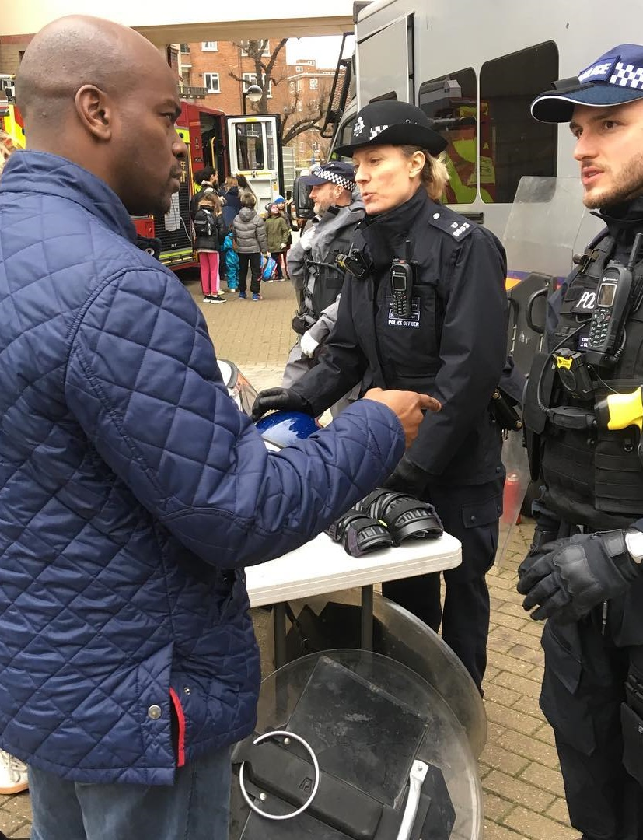





Dear Colleagues,
2019 Extra Paper for London
Policing & Crime, Housing and the Environment. Shaun Bailey, the Conservative candidate for London Mayor, wants to hear the views of CPF groups and supporters across London of these three big policy areas.
This briefing paper contains three sets of discussion questions. CPF Groups may wish to discuss each set of questions on separate occasions. Groups should feel free to discuss as many of as few of the questions as they wish. All responses will help Shaun to understand better the views of members and supporters.
As always, discussions will be more greatly informed if groups are able to include members and non-members from different age groups. Please use the opportunity of this discussion to reach out to new voters in your constituency. Let people know that you are interested in them and want to understand their perspective.
Shaun wants to ensure that as many associations and as many members are able to engage in this vital and wide-ranging discussion. There is no closing date for this brief, although the earlier that groups are able to submit their responses, the better.
Please send your responses to the paper, via CPF.Papers@conservatives.com, using the associated response form published alongside this paper in the News section of the CPF website. All responses to this paper will be forwarded to Shaun’s Political Director.
Thank you. We look forward to hearing your ideas on this important topic and hope that you will also join Shaun to campaign on a street of London near you! For details of where to find him, please visit www.shaunforlondon.uk/events
The CPF Team
John Flick Andrew George
CPF Manager Voluntary Director Vice-Chairman Chairman
www.conservativepolicyforum.com
@ConservativePF

P.S. To help generate interest and awareness, please advertise your local discussion and post a photo of your meeting on your website and social media pages.

Introduction
Shaun’s story is the story of so many Londoners.
Born in a council house. Raised in a deprived part of London. He’s faced the same problems Londoners face every day – high fares, high rent, high crime.
He never thought about politics. Not until he became a youth worker – and saw how politics had failed so many of the city’s young people.
Shaun has the experience that most politicians just don’t have. Running jobs clubs for people who couldn’t find work. Helping young people leave gangs. Working with communities to improve their areas.
And that’s what makes him different. He hasn’t spent a lifetime making political promises he can’t keep. He’s been on the ground, working with people across London – helping to deliver lasting change.
And that’s why he’s standing to be Mayor of London.
Because he understands how best to fix our problems. He knows that if you bring communities together, and give them the support they need, there’s no problem they can’t fix.
That’s what London needs right now. Not another national politician – but someone who’ll bring people together to solve the very real problems we have.
"If I get into politics I could show the kids there’s nowhere a poor kid can't be"
Someone who cares less about politics and more about getting things done.
Someone who’ll be honest with us about what needs to happen.
Shaun’s priorities for Greater London come from real-life experience. They come from listening to the priorities of ordinary Londoners.
SHAUN'S PRIORITIES FOR LONDON
- Cutting violent crime – so we can walk the streets safely.
- Building homes that ordinary Londoners can actually afford to buy – so owning a home is a possibility for everyone.
- Investing in London’s transport network – so everyone has a reliable service that gets them to work on time.
- And protecting Greater London’s economy – so our city’s economy continues to grow through Brexit and beyond.
So that’s what Shaun will do as Mayor of London – show leadership on London’s priorities, bring people together to solve our shared problems and work hard to make a lasting difference.
Shaun has a plan to protect Greater London’s future.

A. Policing & Crime
- Do you agree with increasing stop & search? What could the police do to improve stop and search?
- Do you think criminals should have to wear GPS tags once they are released from prison so that the police always know where they are? Are you concerned about the implications for civil liberties?
- Are mandatory sentences for the possession of harmful weapons or acid too harsh? If not, what length of sentence would you consider most appropriate?
- Would you accept higher council taxes to pay for more police officers? Would you accept a reduction in the levels of public sector workers in order to fund more police officers?
- How to you rate the capacity of youth workers and youth services to turn young people away from crime? Would you prioritise funding towards youth services?
- In your opinion, what would be the greatest single policy the police could adopt that would help with tackling the rise in violent crime?
B. Housing
- Should local councils and other public bodies become more involved in the housing sector? Would you support the public sector building new homes for both rent and buy?
- What policies would you promote to keep rents lows for tenants?
- To make sure we are protecting our precious greenspaces, do we need to redefine what the greenbelt is and, if so, in what way?
- Is it acceptable to lose some commercial and industrial land in order to build more homes in London?
- Do you agree with the building of tower blocks to meet London's housing need? If so, in what circumstances would you support their construction?
C. Environment
  - Are you supportive of the Mayor's Ultra-Low Emission Zone in central London? Is the £12.50 per journey charge for traveling into the zone too expensive?
  - The Mayor wants to expand the ULEZ from central London out to the North and South Circulars. Do you agree with this policy?
  - Do you support the expansion of the cycling network in order to get people out of cars? Have there been any problems with the recent roll-out of cycling lanes and other cycling infrastructure in your local area?
  - Would you purchase an electric vehicle? What would prevent or hinder you from purchasing an electric vehicle?
  - Should schools or councils have the power to ban parents from dropping off their children at the school gates? What measures would you promote in order to get more children walking or cycling to school?
  - Public transport can get people out of personal vehicles, which reduces harmful emissions. Would you accept some increase in transport fares in order to improve public transport in your local area?
Bonus question (for each set of discussion questions)
- Is there any other observation you would like to make or do you have any other thoughts for Shaun?
For further details about Shaun’s campaign, please visit www.shaunforlondon.uk

