Dear Colleagues,
Paper 4/2017: A New Deal for a New Generation
This CPF discussion paper begins with some salutary facts on the challenge we face with younger voters, which we define as those under 40:
- In this year’s general election, two-out-of-three first-time voters (aged 18 or 19) supported Labour;
- Fewer than one-in-five voted Conservative;
- The age at which a voter is more likely to have voted Conservative than Labour has now risen to 47.
It encourages members to reflect on the key policy question: what should the Conservatives be doing in policy terms to help restore the confidence of younger voters?
Clearly, discussions will be more greatly informed if groups include members who can actually speak of their experiences as recent school-leavers: young workers and apprentices, current students, and recent graduates. If your CPF Group does not usually include many members aged under 40, then we would encourage you to use this opportunity to reach out to younger members in your constituency. Please advertise the CPF paper on your Facebook and Twitter pages – and encourage participation of non-members as well – so we can show we are reaching out. Let them know that you are interested in them and want to understand their perspective.
We want to ensure that as many associations and as many members are able to engage in this vital and wide-ranging discussion. (The closing date for this brief is 31 December.)
Please send your responses to the paper, using the response form published on the CPF website, via CPF.Papers@conservatives.com. A summary of responses to this paper will be sent to the Chairman of the Prime Minister’s Policy Board and relevant Ministers within a month of the closing date for submissions.
Thank you. We look forward to your ideas on this important topic.
The CPF Team
www.conservativepolicyforum.com
@ConservativePF

One-Page Summary
A Lost Generation?
In this year’s general election, two-out-of-three first-time voters (aged 18 or 19) supported Labour. Fewer than one-in-five voted Conservative. The age at which a voter is more likely to have voted Conservative than Labour has now risen 47.
Politically, this is a generation, many of whom are not old enough to remember the attacks of 9/11, let alone the 1980s. Most recall nothing of the Cold War’s ideological conflict between socialism and capitalism or the era post-Thatcher, Reagan and Gorbachev when “the end of history” and the victory of economic and political liberalism were prematurely declared.
Time for a New Deal for a New Generation?
- How can we make the Conservative Party once again the party of young people?
- How should we tackle the central issues facing younger voters: (1) tuition fees / student debt, (2) house price unaffordability, and (3) costs of private renting?
- How do we restore the faith of younger people, the majority of whom voted to remain in the EU and for whom Brexit is in danger of being an alienating moment instead of an inspiring moment of national renewal?
- If you could introduce up to three specific policies to signal that we are the party of the next generation, what would they be?
Recent CPF papers have focused on housing, the cost of living and social care. This paper will focus on two of the issues that particularly affect students and the under-25s. Later papers will go on to consider other questions, such as skills and jobs, the environment, and health, social care, and mental health.
- Tuition Fees
- Given that taxpayers already have to pay for students’ unpaid loans, how might the Treasury better contribute towards the costs of students’ higher education?
- Is the current system working fairly? Is the 6% compound interest rate fair? Is the £9,000 cap on fees right?
- How do we get the right balance between supporting the brightest students from disadvantaged backgrounds and allowing our top universities to remain world class?
- What other changes could be made to improve the funding of higher education and its transparency?
- Affordable Rents
- How can Conservatives provide cheaper rented housing so that our young people can save?
- How might we liberate ourselves from the assumption that owning a house is the only way to have a stake in society? How can we deliver a new deal for the next generation?

“This is the reality young people are faced with today: They fork out upwards of £27,000 to go to university, only to be told they have little to no job prospects. They move to London for a career, only to pay an average rent upwards of £1000. They’re charged by estate agents to leave a property, and they’re charged renewal fees when they sign on for another year.” (NME, 13 June 2017)
A Lost Generation?
Some salutary facts on the challenge we face with younger voters:
- In this year’s general election, two-out-of-three first-time voters (aged 18 or 19) supported Labour (compared with two-in-five in 2015 and less than one-in-three in 2010);
- Fewer than one-in-five voted Conservative;
- The age at which a voter is more likely to have voted Conservative than Labour has now risen to 47.
“Millennials” and “Generation Y” are two of the labels given to the generation born between 1977 and 1994. Those born since then are described as “Generation Z”. Millennials are said to be less brand loyal than previous generations and “the speed of the Internet has led the cohort to be similarly flexible and changing in its fashion, style consciousness and where and how it is communicated with.”⁴ For their part, it is expected that Generation Z “will grow up with a highly sophisticated media and computer environment and will be more Internet savvy and expert than their Gen Y forerunners.”
These two cohorts are dealing with a mix of training and accommodation-related issues: the need for the kind of apprenticeships and university courses that will equip them with the skills being sought by employers; seemingly ever-increasing tuition fees; above-inflation interest rates charged on student loans even while they are still receiving their education; a higher education environment that many report as being hostile to free speech; and a rental housing market that is too expensive in urban areas but lacks sufficient availability in rural ones.
With other parties offering easy solutions to the complex issues society faces, it is important to understand the attitudes of these young people towards capitalism and socialism, enterprise and nationalisation. Evidence suggests they are more socially liberal and global in outlook, but also more economically conservative. Their parents were able to enjoy free education and get on the housing ladder relatively easy, but they in turn have had to pay for their education, probably still have debts from going to university, and are unable to save enough money to put down a deposit on a house. Adding insult to injury, many feel that their “future has been taken” from them by the country’s vote to leave the European Union.
The Big Issues
This is a question of intergenerational fairness. As a result of the 2008 financial crisis and QE (quantitative easing), young people have started to become disillusioned with the way the economy is working (or not working) for them. They have become increasingly attracted by the anti-capitalist movement, consistently describing capitalism in negative terms: more than two-in-five choose “greedy” as one of their top three associations, while one-in-three select “selfish” and even “corrupt”. More than twice as many people believe that socialism “delivers most for most people” and is “for the greater good” compared with those who think the same about capitalism (17 and 16 per cent, respectively, compared with just 8 and 7 per cent). More than three quarters say that water, electricity, gas and the railways should be in the hands of the public sector.⁶
Although conservatism is viewed by many in a similarly negative way, perceptions that it is “selfish”, “greedy” and “corrupt” are at least balanced by similar proportions who view it as “principled” and “practical”. It is also significantly more likely than capitalism to be viewed as “delivering most for most people” and “forward-looking”.
Reasons why a majority of young people no longer vote Conservative can be attributed to a “perfect storm” of post-crash QE and policy choices ranging from tuition fees and “eye-watering” monthly compound interest rates, to unaffordable housing, rents that consume half a starting salary, and a “lost decade in terms of wage growth”. An exit poll of 18-34 year-olds revealed some of the top reasons why young people voted the way they did:
37.3% | preferring one party’s policies over another’s
29.8% | health and social care policy
28.7% | party leader would make a better Prime Minister
25.8% | best to navigate Britain through Brexit
25.6% | education policy
19.8% | immigration policy
18.7% | security policy
A recent survey identified more about the issues that young people believe should be discussed more often by politicians. Among the under-40s, the top two were health and climate change, followed by education and housing. Among 18-24-year-olds, just the order was different – climate change and education, followed by health and housing:
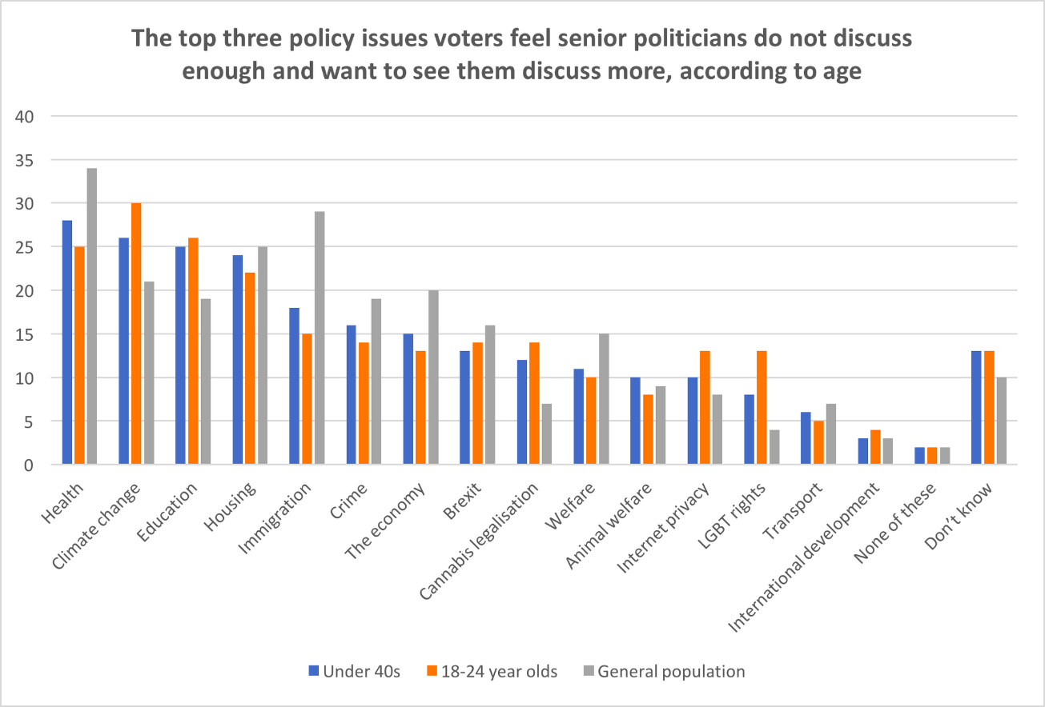
Time for a New Deal for a New Generation?
Recent CPF papers have focused on housing, the cost of living and social care. This paper will focus on two of the issues raised above that particularly affect students and the under-25s. Later papers will go on to consider questions of skills and jobs, the environment, and broader issues of health care, including mental health. However, we want to start by asking some of the bigger questions.
Politically, this is a generation, many of whom are not old enough to remember the attacks of 9/11, let alone the 1980s. Most recall nothing of the Cold War’s ideological conflict between socialism and capitalism or the era post-Thatcher, Reagan and Gorbachev when “the end of history” and the victory of economic and political liberalism were prematurely declared.
Questions for discussion
- How can we make the Conservative Party once again the party of young people?
- How should we tackle the central issues facing younger voters: (1) tuition fees / student debt, (2) house price unaffordability, and (3) costs of private renting?
- How do we restore the faith of younger people, the majority of whom voted to remain in the EU and for whom Brexit is in danger of being an alienating moment instead of an inspiring moment of national renewal?
- If you could introduce up to three specific policies to signal that we are the party of the next generation, what would they be?
- Tuition Fees
“A powerful university cartel is interwoven with parts of the establishment and cares little about its students, who many academics view as an inconvenience. The universities are just focused on the money. The 2017 general election brought the issue of student costs to the foreground.” (UK2020, 30 August 2017)
“While students are still at university, their debt pile grows at an interest rate above 6 per cent, which officials at the Department for Education have accurately described as “bonkers”. The government’s unusual methodology for calculating interest increases lifetime repayments by £40,000 for higher earners, according to analysis by the Institute for Fiscal Studies, compared with a system in which no interest accrues beyond consumer price inflation.” (The Times, 18 October 2017)
The problem
In 1980, there were only 68,000 people starting university – this autumn there will be more than 500,000. Twice as many people are now getting a degree as were getting five O-levels in the early 1980s. These students are now graduating with debts averaging in excess of £40,000 (and, with the replacement of maintenance grants by loans, around £53,000 for students from the poorest families). From the first day of their studies, they are charged an interest rate that currently stands at 6.1 per cent, which means that the amount they owe will double every 12 years. Total student debt is expected to reach over £100 billion (2014/15 prices) in 2018 and is rising by £13bn a year. Yet, a major review into university funding in 2010 estimated that around 60 per cent of graduates will not repay their loans in full before the 30-year limit when they are written off.
Yet, questions need to be asked about the individual and societal benefits of all this indebtedness. After factoring in the cost of going to university, including average student debt levels, and the ability of apprentices to earn while learning, higher apprenticeships at level 5 in fact result in greater lifetime earnings than undergraduate degrees from non-Russell Group universities. Similarly, a higher apprenticeship at level 4 results in similar lifetime earnings on average to an undergraduate degree from a non-Russell Group university:
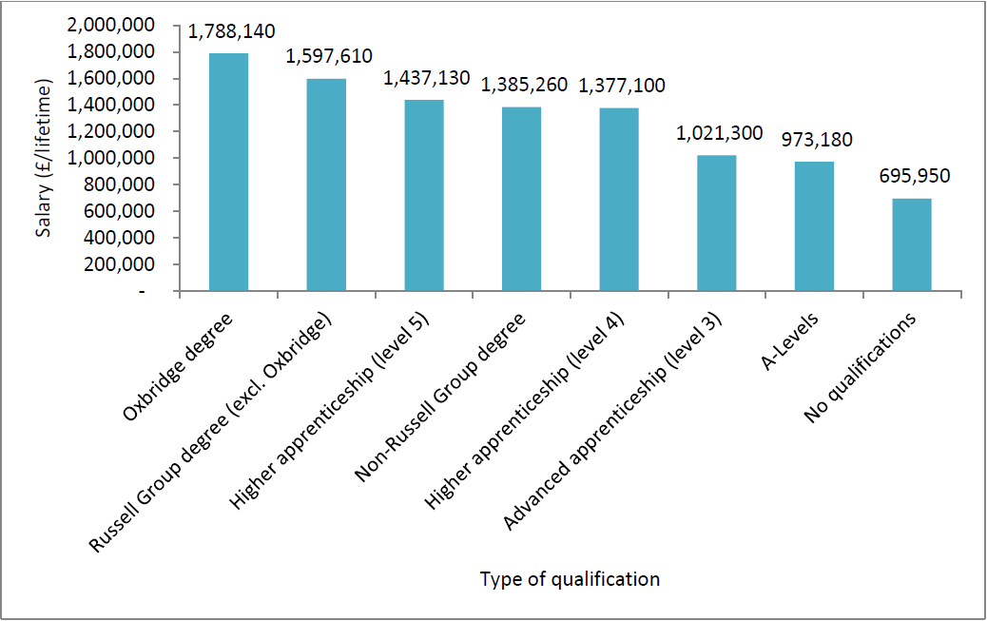
Ideas
Several ways forward have been suggested:
- undertake a major review of the fees system;
- introduce a graduate tax;
- focus on vocational qualifications as an alternative route for young people;
- encourage more institutions to offer cut-price two-year degrees.
Questions for discussion
- Given that taxpayers already have to pay for students’ unpaid loans, how might the Treasury better contribute towards the costs of students’ higher education?
- Is the current system working fairly? Is the 6% compound interest rate fair? Is the £9,000 cap on fees right?
- How do we get the right balance between supporting the brightest students from disadvantaged backgrounds and all allowing our top Universities to remain world class?
- What other changes could be made to improve the funding of higher education and its transparency?
- Affordable Rents
“If we’re going to make this a country that works for everyone, we need housing that works for everyone. And that’s true regardless of whether you’re an owner-occupier, a private rental tenant, or living in social housing.” (Sajid Javid, 19 September 2017)
The problem
Less than one-in-five people live in rented accommodation at market price in the UK (18.0 per cent). This compares with almost a half of the population in Switzerland (49.2 per cent), close to two fifths in Germany (39.9 per cent) and Denmark (37.9 per cent), around three tenths in Sweden (34.0 per cent), the Netherlands (30.3 per cent) and Austria (29.7 per cent), and just over one fifth in Luxembourg (21.7 per cent).
Yet, of these people, more than one-in-three are overburdened by housing costs in the UK (35.4 per cent), spending more than two-fifths of their income on rent and other living costs associated with their home. This is a significantly higher proportion than our European neighbours named above: Switzerland (17.2 per cent), Germany (22.8 per cent), Denmark (31.1 per cent), Sweden (18.0 per cent), the Netherlands (27.1 per cent), Austria (15.6 per cent) and Luxembourg (23.2 per cent). In fact, the only European countries, besides half-a-dozen in Eastern Europe, that have higher proportions that are overburdened by their rental housing costs are Greece (84.6 per cent) and Spain (43.0 per cent). By comparison, fewer than one-in-twenty of those who live in owner-occupied housing are overburdened by their housing costs in the UK (4.8 per cent of those with a mortgage and 4.3 per cent of those with no outstanding mortgage).
The private rented sector has typically been associated with young professionals and students. Between 2005-06 and 2015-16, however, the proportion of households in the private rented sector with children increased from 30 to 36 per cent. Given the sizeable growth in the overall number of private renters over this period, this equates to about 945,000 more households in the private rented sector with children.
Other concerns among private tenants include the quality of the housing stock and the security of tenancy. The private rented sector has the highest proportion of homes that fail to meet the government’s decent homes standard (28 per cent, compared with just 13 per cent in the social rented sector and 18 per cent among owner-occupied homes).¹⁹ One study found that more than three-in-five tenants had experienced gas leaks, electrical hazards, leaking roofs or windows, damp, mould, or animal infestations between 2013 and 2014.
The most common type of tenancy in the UK, assured shorthold tenancies, offer less protection from eviction than older types of tenancy, such as pre-1997 assured tenancies or pre-1989 regulated tenancies. Assured shorthold tenancies give landlords the absolute right to possession, allowing them to serve a two-month eviction notice to tenants after the tenancy’s fixed-term period ends or in the case of a rolling periodic arrangement. By contrast, tenants in Germany enjoy greater security of tenure, cheaper rents relative to income, and large levels of institutional investment. For instance, Germany has stricter regulations on landlords, such as unlimited leases, a requirement to prove contract violation on behalf of the tenant in order to evict them, and the power to transfer tenancies to a new landlord if a property is sold.
Questions for discussion
- How can Conservatives promote cheaper rented housing so that our young people can save?
- How might we liberate ourselves from the assumption that owning a house is the only way to have a stake in society? How can we deliver a new deal for the next generation?

People to seek opinions from
Young people!

Endnotes

Dear old people, this is why young people voted, NME, 13 June 2017: link
43 per cent of 18-24 year-olds voted Labour in 2015, compared with 27 per cent Conservative; for 2010 the figures were 31 and 30 per cent, respectively. How Britain voted in 2015, Ipsos Mori, 26 August 2015: link and How Britain Voted in 2010, Ipsos Mori, 21 May 2010: link
How Britain voted at the 2017 general election, YouGov, 13 June 2017: link
Generations X,Y, Z and the Others, WJSchroer: link
Nearly three quarters (73 per cent) of 18 to 24 year-olds voted to remain in the EU. How the United Kingdom voted on Thursday… and why, Lord Ashcroft Polls, 24 June 2016: link
Public opinion in the post-Brexit era: Economic attitudes in modern Britain, Legatum Institute, October 2017: link
Labour market charts, Resolution Foundation, 14 June 2017: link
Young people reveal the reasons they voted in the 2017 general election, NME, 9 June 2017: link
Conservatism rejuvenated: appealing to the under 40s, Bright Blue, 30 September 2017: link
Timebomb: How the university cartel is failing Britain’s students, UK2020, 2017: link
Fee Fall, The Times, 18 October 2017: link
10 charts that show the effect of tuition fees, BBC News, 8 July 2017: link
Student loan statistics, House of Commons Library, 21 June 2017: link
Student finance: what parents need to know, Which? University, 1 January 2017: link
Levels of Success: The potential of UK apprenticeships, The Sutton Trust, October 2015: link
Sajid Javid’s speech to the National Housing Federation conference 2017, Department for Communities and Local Government, 19 September 2017: link
Distribution of population by tenure status, type of household and income group, EU-SILC survey, 25 September 2017: link
Housing cost overburden rate by tenure status, EU-SILC survey, 25 September 2017: link
English housing survey: headline report 2015-16, Department for Communities and Local Government, March 2017: link
Safe and decent homes: solutions for a better private rented sector, Shelter, 2014: link
Lessons from Germany: tenant power in the rental market, Institute for Public Policy Research, 2017: link
Towards a sustainable private rented sector: the lessons from other countries, London School of Economics, 2011: link

